3.Chapter 2: Specification and Conception

2.1 Introduction
After presenting the general context of our project, we will dedicate this chapter to present our project in a formal way. We will do a detailed and complete analysis of different needs related to our application which will include:
- specifying the functional and non-functional requirements of our system.
-an identification of the main actors that are going to interact with our application.
-presentation of the global use case diagram
-presentation of different detailed use case diagrams

2.2 Functional requirements

In the following, we will present the functional requirements of our project.
Functional requirements express the actions that the system must execute in response to user requests. In our case, our application must respond to the following needs:

Registration
The application must allow users to register in order to access the application
Authentication
It allows the user to connect using his email address in order to benefit from the application’s features.
Consulting workout
It allows the user to open his account every day, and check his workout for that day.
Chat
It allows the user to connect and chat with other users.
Consulting support groups
It allows the user to consult available support groups and to join them
Creating support groups
It allows the user to create support groups and to invite people to these groups or make them public.
Settings:
It allows the use to consult or update settings
Goal:
It allows the user to consult or choose his goal.
Creating workout
It allows the Admin to create a workout
Consulting users
It allows the Admin to consult all the users
Changing user’s workout
It allows the admin to consult or change the user’s workout

2.3 Non-Functional requirements

We identify non-functional needs which are operational constraints that count on the performance of the application. They are summarized as follows:

- Scalability and maintenance: The application must be able to adapt to any change on the implementation side (updating frameworks) in order to guarantee its evolution and flexibility. Also, it must offer a clearly readable, understandable code and modular.

- Extensibility: The system must be scalable and must take into account the possibility of its extension by adding new features.

- Security: The Application must ensure the security of personal information

- Performance: The modules must optimize the treatments and reduce the execution time.

- Ergonomics: The application is user-friendly, simple to use, ergonomic and adapted to the use

- Reusability: The components of the system can be reused for the development of a different applications.

- Modularity: The application is well structured as modules to ensure better readability, a reduction in the risk of error and the possibility of selective tests
2.4 Use-case diagrams
A use case diagram is a behavior diagram that visualizes the observable interactions between actors and the system under development. The diagram consists of the system, the related use cases and actors.

In this section, we present the needs of our system in a formal way using the Unified Modeling Language (UML) use case diagrams. These various features are described in the diagrams below.

2.4.1 Global use-case diagram:

The Figure describes in a general way the actors of the system as well as the functionalities. A detailed description of the different use-case will follow.
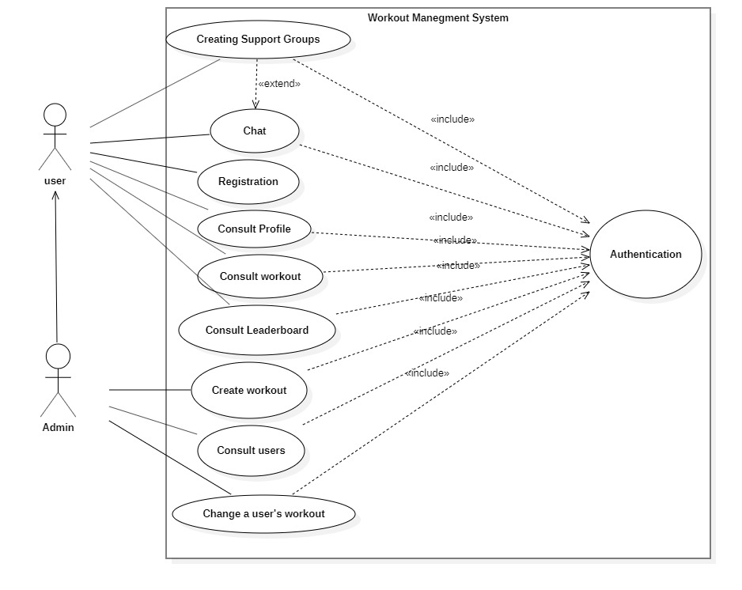
Figure 2.1: Global use case diagram
2.4.2 Authentication use-case diagram:
Figure represents the use case diagram of authentication. The user will be able to have access to the application with his email and password as well as restore access to the application through Restore Password Action in case of forgotten password.
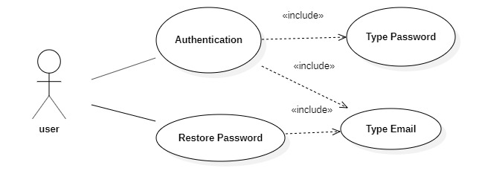
Figure 2.2: Authentication use case diagram

Table 2.1 describes in details the authentication use case scenario:
Actor | Admin, User
Objective | Get authenticated and access to the application’s features
Pre-condition | Registered email and password
Post condition | Redirection to Dashboard Page
Nominal Scenario | 1-User request the authentication interface  2- the application displays the interface  3-user fills in the necessary and valid fields  4-System checks the data entered and displays the dashboard Page
Alternative scenario | 1-User enters incorrect data  2-System displays an error message  3-Resumption of stage 3 of the nominal scenario
Table 2.1: Authentication use case scenario

Table 2.2 describes in details the restore password scenario:

Actor | User, Admin
Objective | Restore Password
Pre-condition | Valid key
Pre-condition | The user has already registered
Post-condition | The user’s password changes
Nominal Scenario | 1-User requests the Forgotten password interface  2-System displays the interface  3-User fills in the necessary and valid fields  4-The system sends an email with a password reset token and displays a message success  5-User retrieves the token and use it to change his password
Alternative scenario | 1-User enters an incorrect email address  2-System displays an error message  3-Resumption of stage 3 of the nominal scenario
Table 2.2: Restore password use case scenario

2.4.3 Workout Management use-case diagram
Figure 2.3 represents the use case diagram of workout management: Any user will be able to consult the workout page to see his exercises for that specific day. Admins I’ll be able to create, modify or delete workouts.
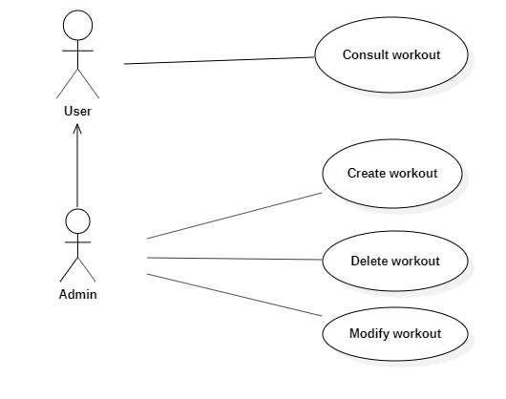
Figure 2.3: Workout Management Use-Case Diagram

Table 2.4 describes in details the consult workout scenario:

Actor | User
Objective | Consult Workout
Pre-condition | The user is authenticated
Pre-condition | The user has already chosen his goals and set his conditions
Post-condition | The user is shown the workout
Nominal Scenario | 1-User requests the Workout interface  2-System displays the interface  3-User retrieves his daily workout
Alternative scenario | 1-User requests the Workout  2-System displays the interface for choosing the goal  3-User sets the goal and conditions  3-Resumption of stage 2 of the nominal scenario
Table 2.4: Consult workout use case scenario

Table 2.5 describes in details the create workout scenario:

Actor | Admin
Objective | Create a workout
Pre-condition | The admin needs to be authenticated
Post condition | The workout is saved and the admin is redirected to the interface containing the list of workouts with the new workout added
Nominal Scenario | 1-User request the create workout interface  2- the application displays the interface  3-user fills in the necessary and valid fields  4-System checks the data entered  5-The system saves the workout and resets the create workout interface’s fields.
Alternative scenario | 1-User enters already existent workout name  2-System displays an error message  3-Resumption of stage 3 of the nominal scenario

Table2.5: Create workout use case Scenario

Table 2.6 describes in details the create workout scenario:
Actor | Admin
Objective | Modify a workout
Pre-condition | The admin needs to be authenticated
Post condition | The modification is saved and the admin is redirected to the interface containing the list of workouts with the new workout added
Nominal Scenario | 1-User request the workout list interface  2- the application displays the interface  3-The user choses the workout to modify  3-user fills in the necessary and valid fields  4-System checks the data entered  5-The system saves the modification and redirect the user to the workout list interface
Alternative scenario | 1-User doesn’t enter the modification  2-User enter invalid information
Table 2.6: Modify workout use case scenario

Table 2.7 describes in details the delete workout scenario:
Actor | Admin
Objective | Delete a workout
Pre-condition | The admin needs to be authenticated
Post condition | The workout is deleted and the admin is redirected to the interface containing the list of workouts without the workout that got deleted
Nominal Scenario | 1-User request the create workout interface  2- the application displays the interface  3-User choose the workout to be deleted  5-The system deletes the workout and the admin is redirected to the interface containing the list of workouts without the workout that got deleted
Alternative scenario | 1-User doesn’t delete the workout
Table 2.7: Delete Workout use case scenario

2.4.4 Chat Management use case Diagram
Figure 2.4 represent the use case diagram of chats Management. After authentication, the user can look up and start a conversation with him as well create a group chat with multiple user which server as a support group.
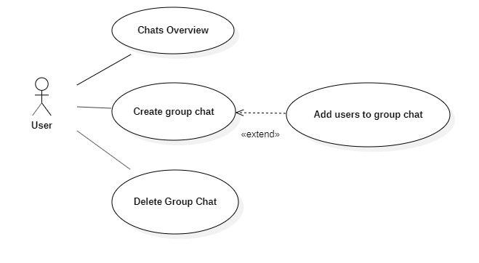
Figure 2.4: Chats Management Use Case Diagram

Table 2.8 describes in details the chats overview scenario:

Actor | User
Objective | Consult Chats
Pre-condition | The user is authenticated
Pre-condition | The user has already chosen his goals and set his conditions
Post-condition | The user is shown the list of chats
Nominal Scenario | 1-User requests the chats interface  2-System displays the interface
Alternative scenario | 1-User didn’t start any chat  2-The user is redirected to an empty chats interface
Table 2.8: Consult Chats Use Case Scenario

Table 2.9 describes in details the Create Group Chat Scenario:

Actor | User, Admin
Objective | Start a chat
Pre-condition | The user needs to be authenticated
Post condition | The user can send messages to the other user in the chat
Nominal Scenario | 1-User request the chats interface  2- the application displays the interface  3-user fills in the name of the user  4-System shows users with relative name  5-User choose who he wants to start a conversation with  5-The system create the conversation and the user is redirected to the conversation interface
Alternative scenario | 1-User enters a wrong username  2-System doesn’t display any users  3-User enters the correct username  3-Resumption of stage 4 of the nominal scenario

Table2.9: Create workout use case Scenario

Table 2.9 describes in details the create group chat scenario:
Actor | Admin
Objective | Create a group chat
Pre-condition | The user needs to be authenticated
Post condition | The group chat is saved and the users within it can chat with each other
Nominal Scenario | 1-User request the group chat interface  2- the application displays the interface  3-user fills in the group chat name field  4-System creates the chat group
Alternative scenario | 1-User enters already existent group chat name

Table2.9: Create workout use case Scenario

Table 2.91 describes in details the add users to group chat scenario:
Actor | Admin
Objective | Add users to group chat
Pre-condition | The user needs to be authenticated
Pre-condition | The group chat is already created
Post condition | The users are added to the group chat
Nominal Scenario | 1-User chooses the group chat  2- The user requests the add users’ interface  3-System displays the add users interface  4-Users enter the name of the users to add  5-The users are added to the group chat
Alternative scenario | 1-User enters inexistant user name  2-System doesn’t show any user  3-Resumption of stage 4 of the nominal scenario

Table2.9: Create workout use case Scenario

2.5 Identification of Actors
An actor is an entity external to the system. It represents a person or other computer system waiting for one or more services offered by an interface access. It interacts with the system by sending or receiving messages
The actors that will interact with the system are:
Administrator: This is the person who manages the entire application which include managing users, and workouts.
User: He’s the basic user that will benefit from the features of the application.

Conclusion
Throughout this chapter, We presented the functional and non-functional needs related to our application, as well as the main functionalities such as workout and chat management, and in the end we presented the different use-case diagrams and scenarios of those functionalities.

